SCHOOL OF COMPUTER SCIENCE AND ARTIFICIAL INTELLIGENCE |  |  |  |  | DEPARTMENT OF COMPUTER SCIENCE ENGINEERING
ProgramName:B. Tech |  |  |  | Assignment Type: Lab |  |  | AcademicYear:2025-2026
CourseCoordinatorName |  |  |  | Venkataramana Veeramsetty
Instructor(s)Name |  |  |  | Dr. V. Venkataramana (Co-ordinator)  Dr. T. Sampath Kumar  Dr. Pramoda Patro  Dr. Brij Kishor Tiwari  Dr.J.Ravichander  Dr. Mohammand Ali Shaik  Dr. Anirodh Kumar  Mr. S.Naresh Kumar  Dr. RAJESH VELPULA  Mr. Kundhan Kumar  Ms. Ch.Rajitha  Mr. M Prakash  Mr. B.Raju  Intern 1 (Dharma teja)  Intern 2 (Sai Prasad)  Intern 3 (Sowmya)  NS_2 ( Mounika)
CourseCode |  |  | 24CS002PC215 | CourseTitle |  | AI Assisted Coding
Year/Sem |  |  | II/I | Regulation |  | R24
Date and Day  of Assignment |  |  | Week3 - Wednesday | Time(s)
Duration |  |  | 2 Hours | Applicableto  Batches
AssignmentNumber:6.3(Present assignment number)/24(Total number of assignments)
 | Q.No. | Question |  |  |  |  |  | ExpectedTime  to complete
 | 1 | Lab 6: AI-Based Code Completion – Classes, Loops, and Conditionals  Lab Objectives:  - To explore AI-powered auto-completion features for core Python constructs.  - To analyze how AI suggests logic for class definitions, loops, and conditionals.  - To evaluate the completeness and correctness of code generated by AI assistants.  Lab Outcomes (LOs):  After completing this lab, students will be able to:  - Use AI tools to generate and complete class definitions and methods.  - Understand and assess AI-suggested loops for iterative tasks.  - Generate conditional statements through prompt-driven suggestions.  - Critically evaluate AI-assisted code for correctness and clarity.  Task Description#1 (Classes)  - Use AI to complete a Student class with attributes and a method.  - Check output  - Analyze the code generated by AI tool  Instructions:  - Initialize class with attributes like name, roll no, marks  - Method to display student details  - Method to calculate grade based on marks (A:>=90, B: >=75, C: >=60, else Fail)  Start Writing code and auto complete using any AI tool  VS CODE:  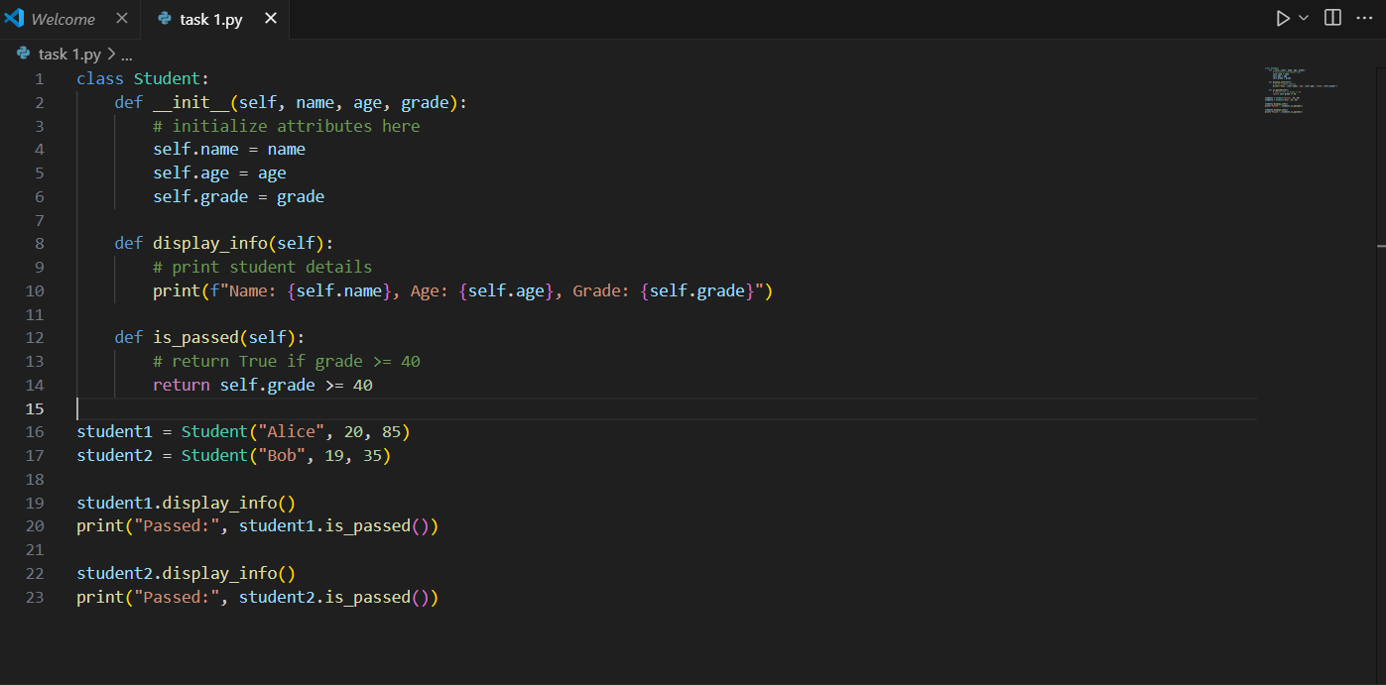  CURSOR AI CODE:  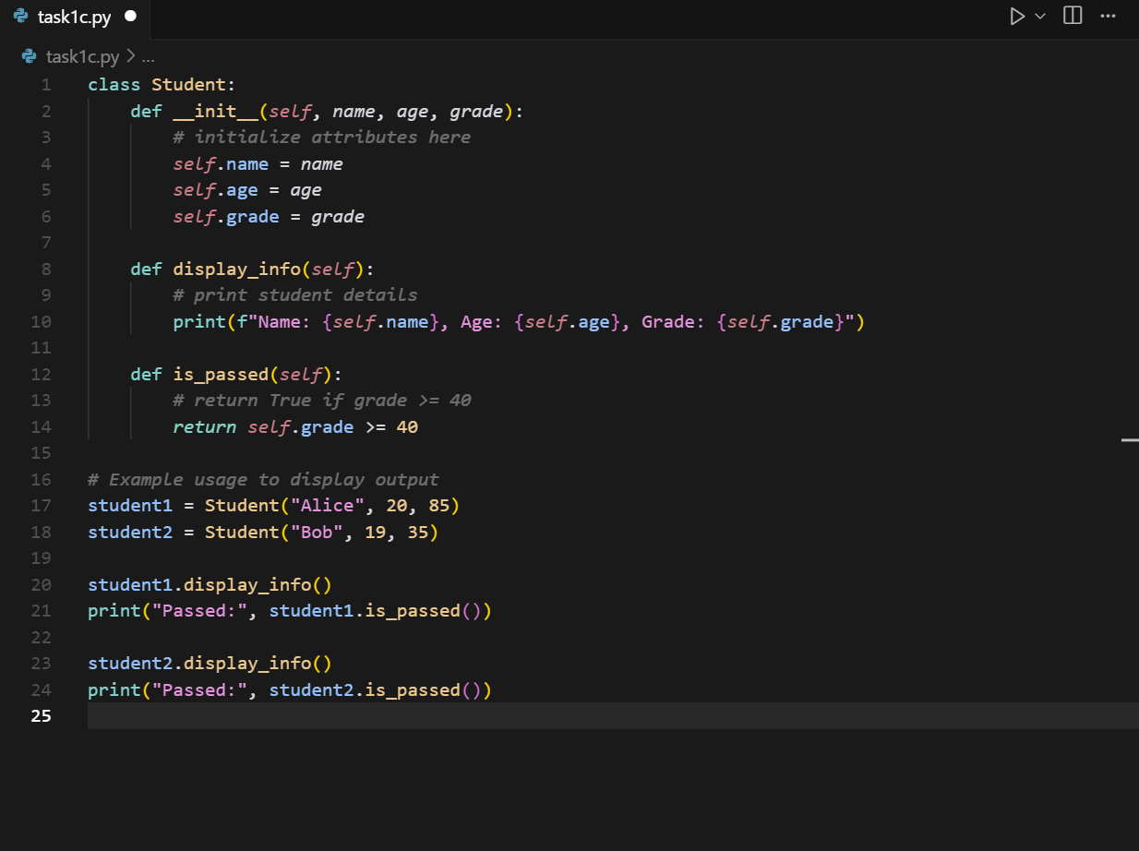  Expected Output#1  - Class with constructor and display_details() method  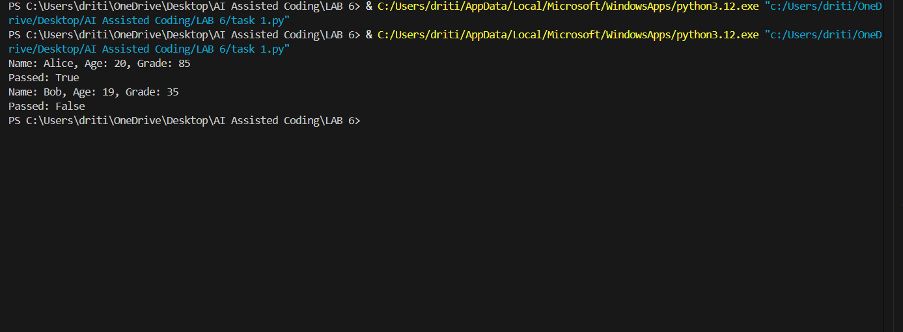  CURSOR OUTPUT:  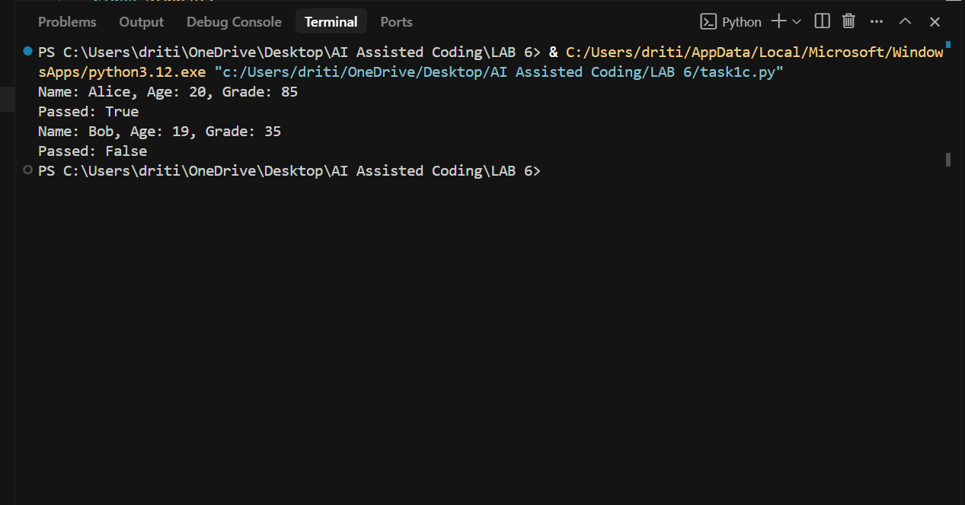  EXPLANATION :  - The VS Code AI version provides a direct and minimal implementation of the Student class. It defines attributes, methods, and object usage in a straightforward way without additional comments or separation. The focus is mainly on functionality rather than readability.  - The Cursor AI version offers the same functionality but presents the code in a more structured and readable manner. It includes a comment section (# Example usage to display output) that separates the class definition from the usage part, making the code clearer and easier to follow.  In short, VS Code AI focuses on quick, barebones implementation, while Cursor AI emphasizes clarity and documentation for better understanding.  Task Description#2 (Loops)  Prompt AI to complete a function that prints the first 10 multiples of a number using a loop.  - Analyze the generated code  - Ask AI to generate code using other controlled looping  Write code using For Loop, later complete code using While Loop  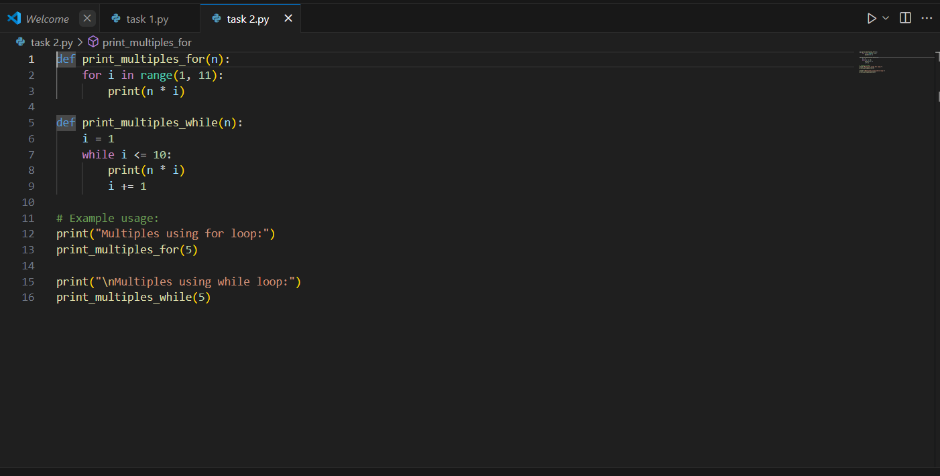  CURSOR CODE:  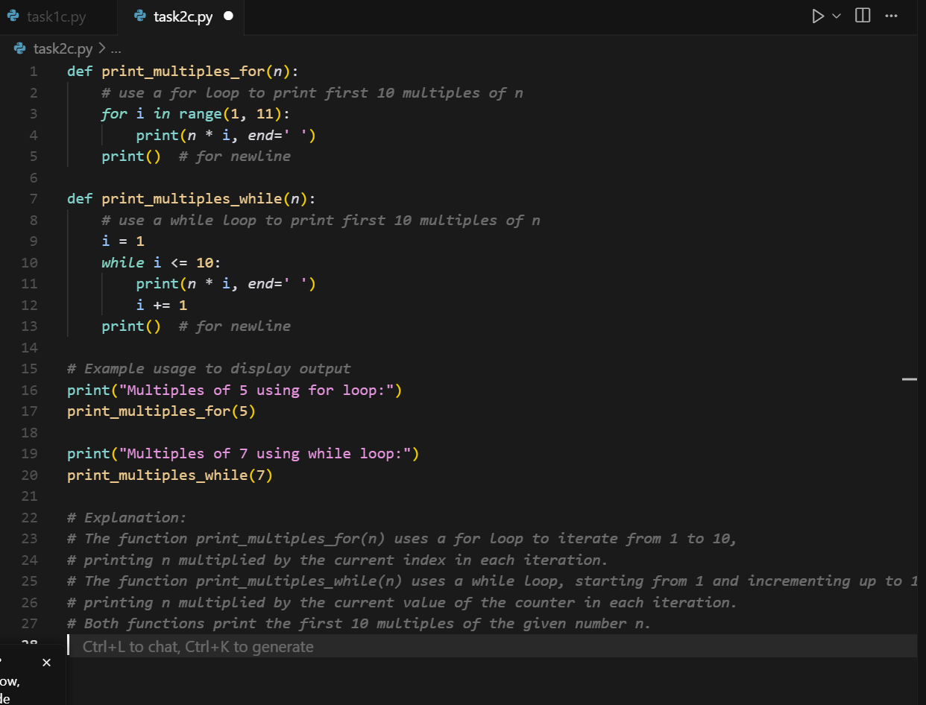  Expected Output#2  - Correct loop-based implementation  - 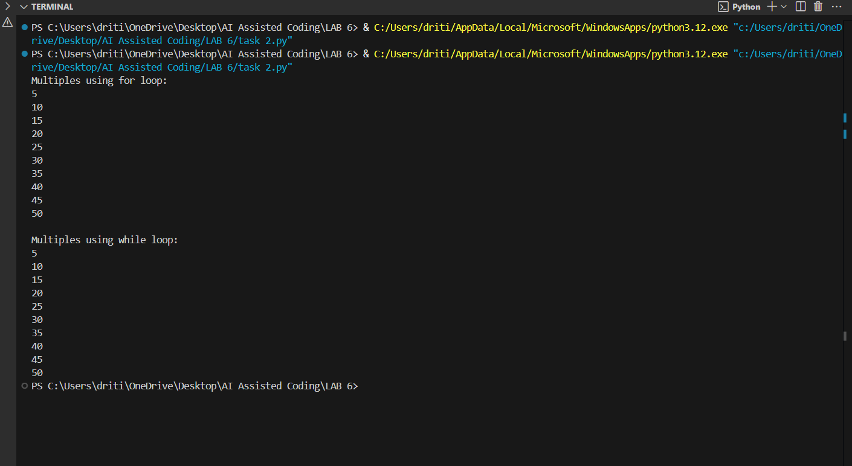  - CURSOR OUTPUT:  - 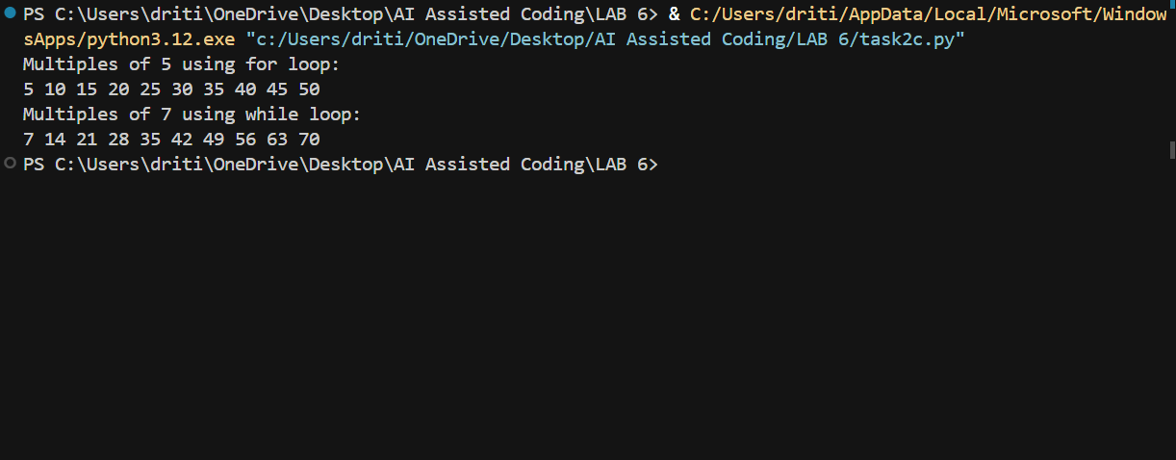  - EXPLANATION:  - The VS Code AI version gives a simple and direct implementation of the two functions. It prints multiples using both for and while loops, but the output is displayed line by line without extra formatting or comments. The focus is mainly on functionality.  - The Cursor AI version produces a more structured and polished implementation. It adds inline comments explaining each part of the code, uses end=' ' to print multiples in the same line, and includes a final print() for formatting. It also provides an explanation section at the end, making the code easier to understand.  In short, VS Code AI is minimal and functional, while Cursor AI is more detailed, readable, and user-friendly with explanations.  Task Description#3 (Conditional Statements)  - Ask AI to write nested if-elif-else conditionals to classify age groups.  - Analyze the generated code  - Ask AI to generate code using other conditional statements  - 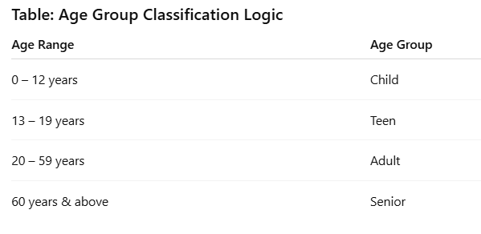  Expected Output#3  - Age classification function with appropriate conditions and with explanation  - 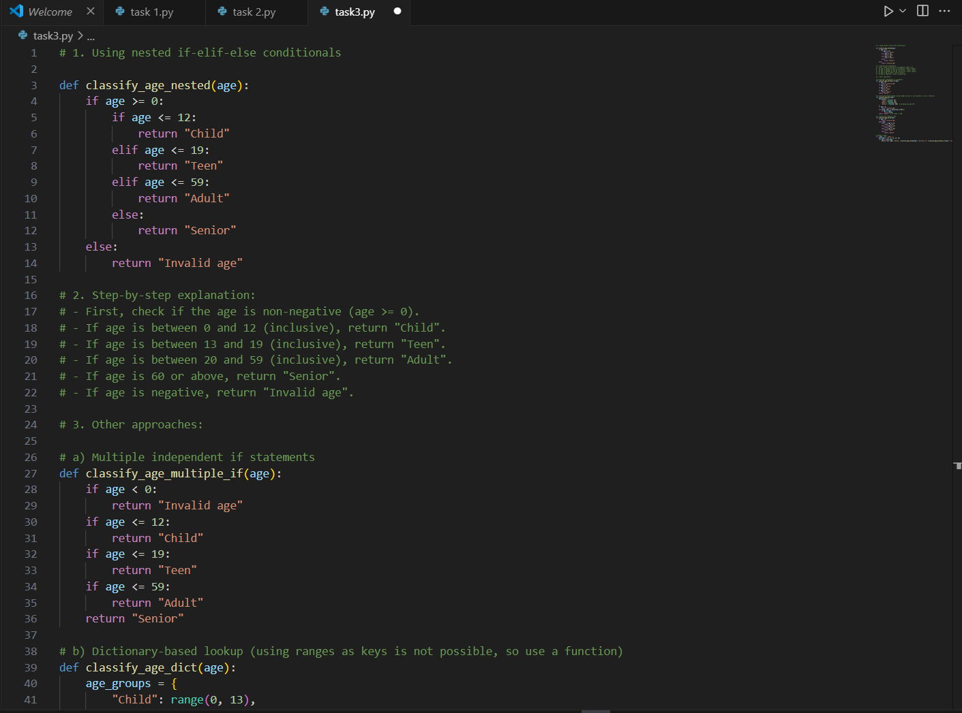  - 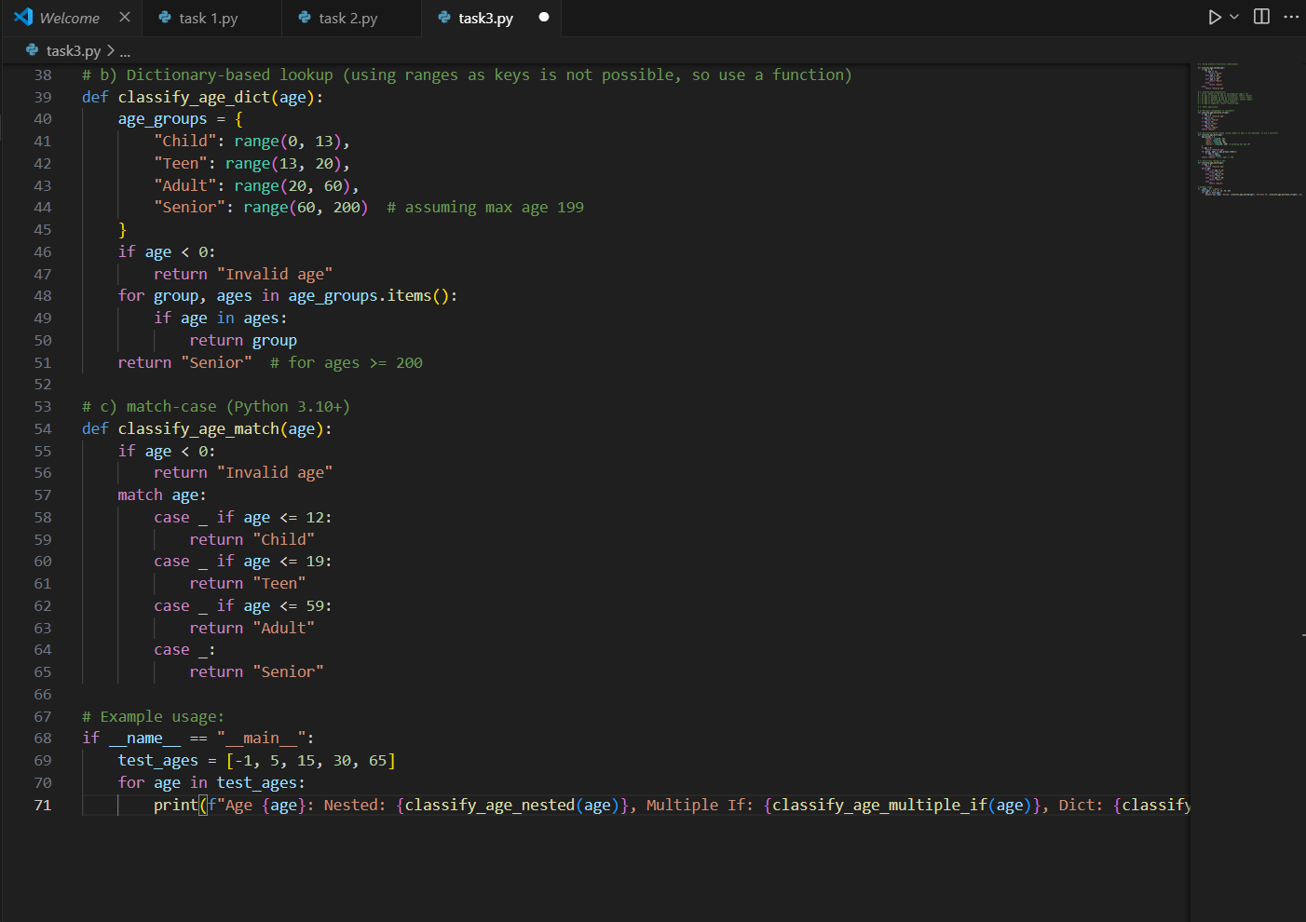  - CURSOR AI CODE:  - 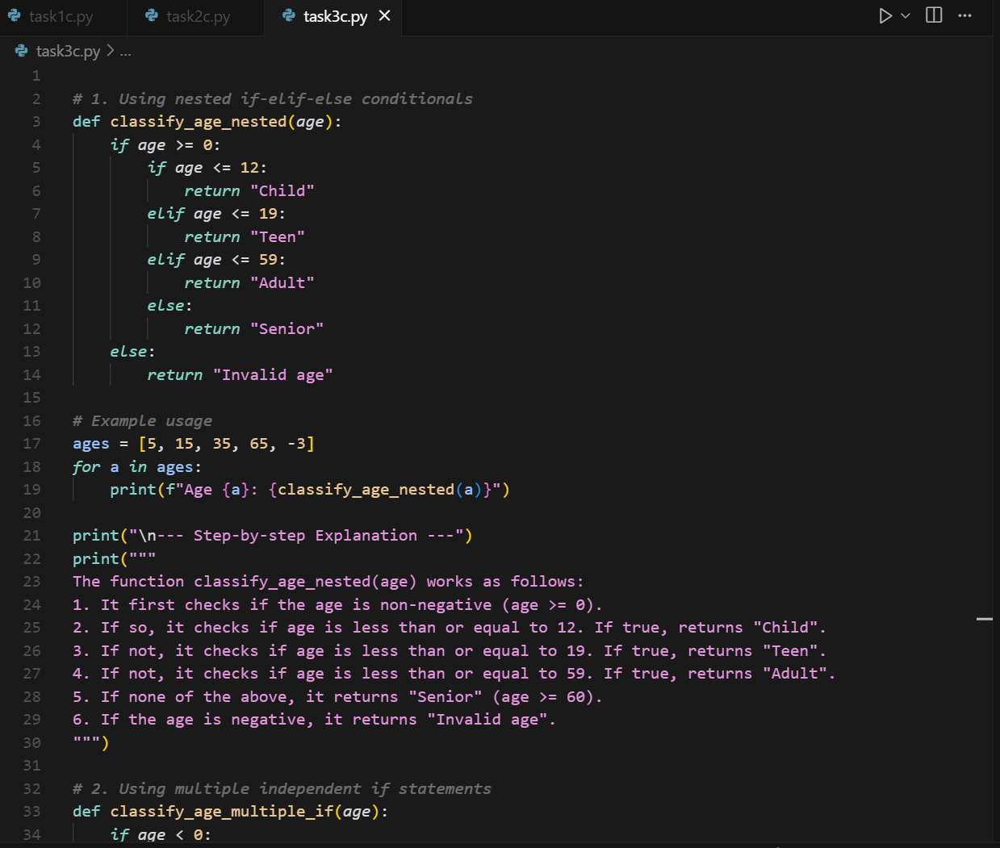  - 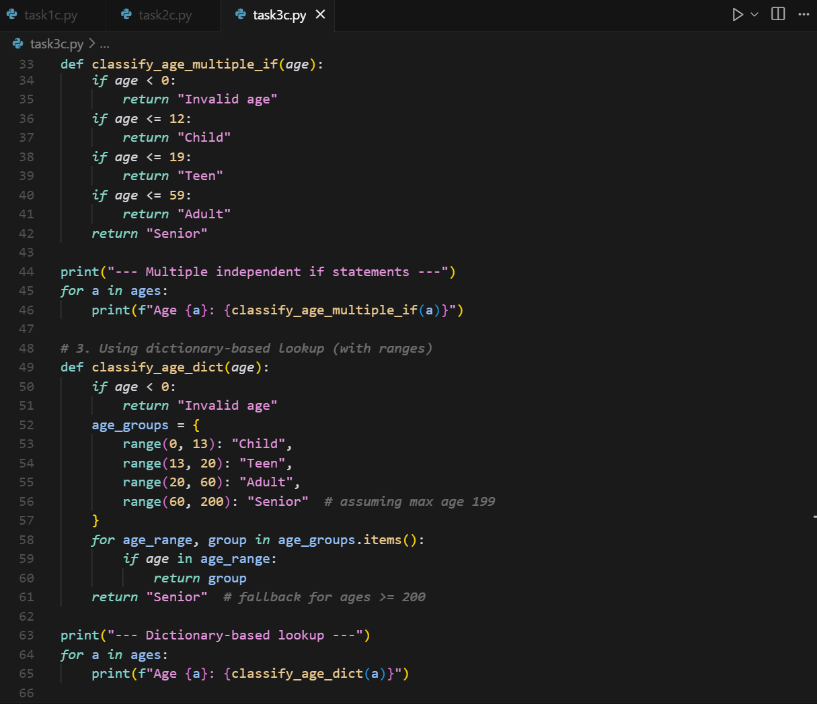  - 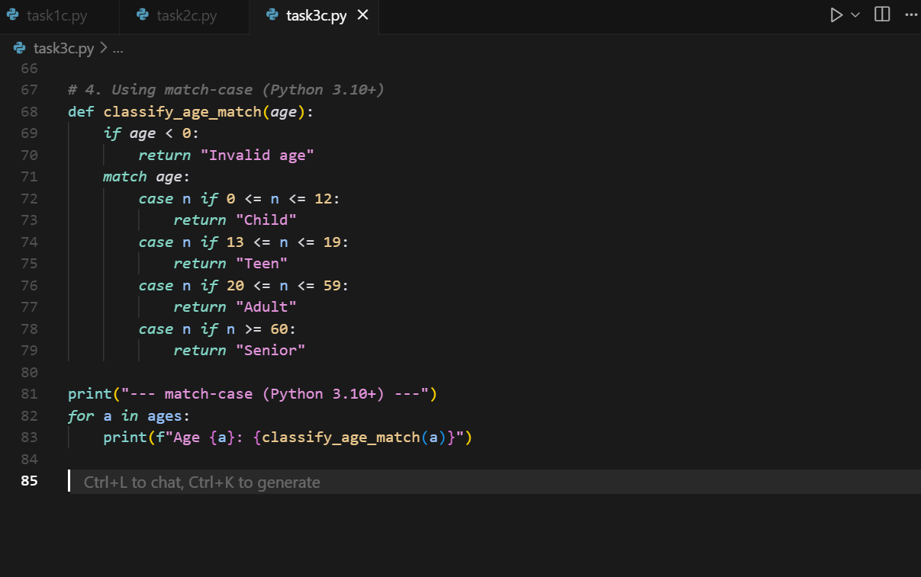  - OUTPUT:  - 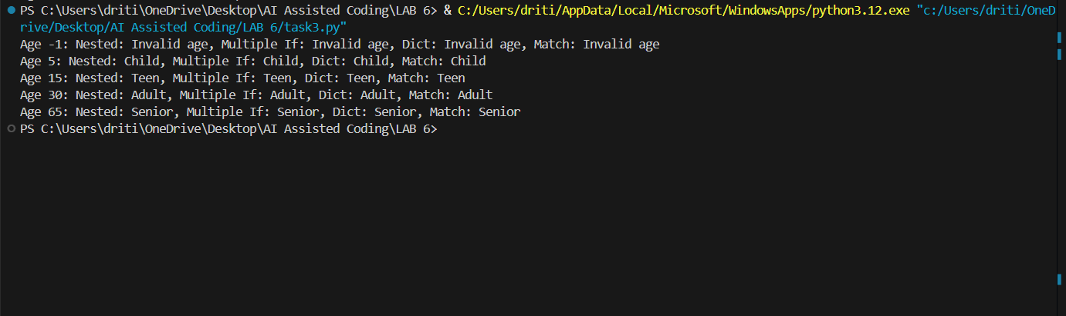  - CURSOR OUTPUT:  - 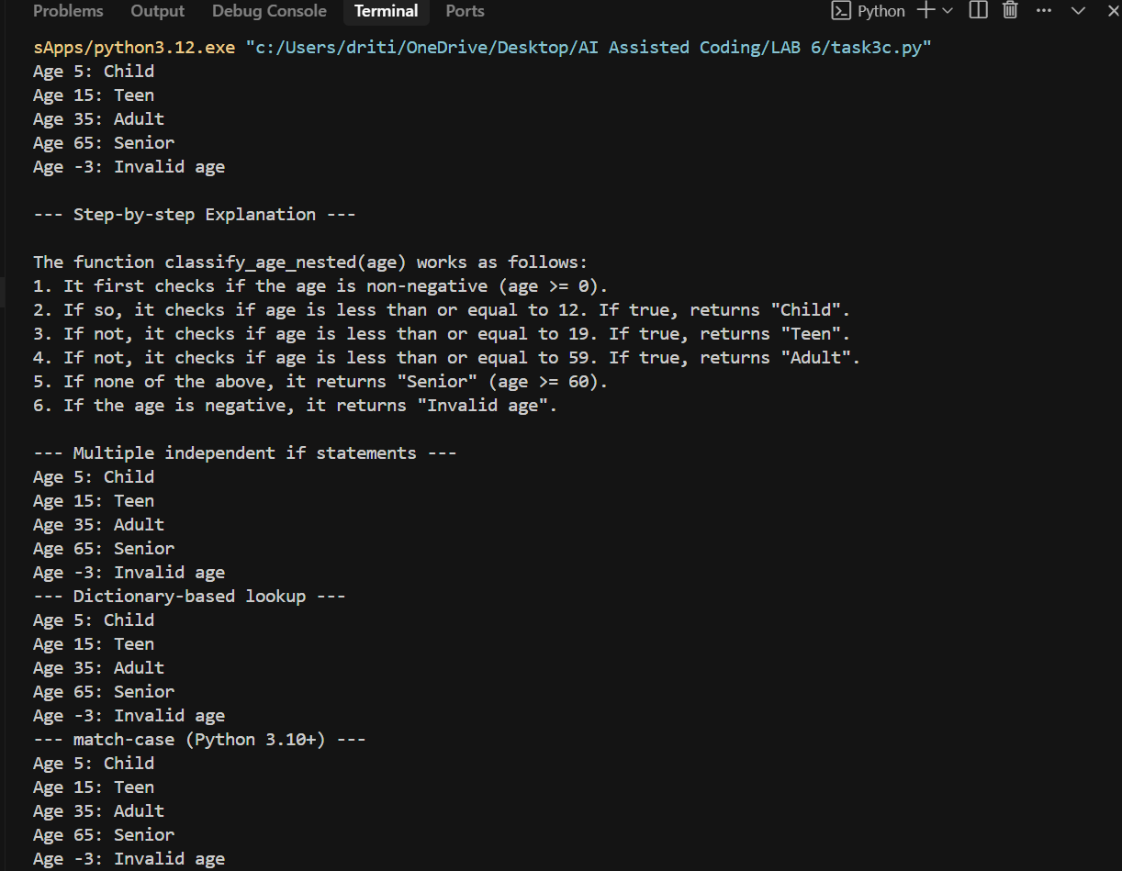  - EXPLANATION:  - The VS Code AI version focuses mainly on functionality. It defines multiple approaches (nested if, multiple if, dictionary, and match-case) but keeps the code compact with minimal or no comments. The test cases are included, but explanations are not provided, making it less descriptive.  - The Cursor AI version provides the same approaches but with more structure and explanation. It adds headings, comments, and step-by-step descriptions after each implementation. The test outputs are clearly separated with print statements, making the code easier to read and understand.  In short, VS Code AI is concise and code-focused, while Cursor AI is detailed, well-documented, and learner-friendly.  Task Description#4 (For and While loops)  - Generate a sum_to_n() function to calculate sum of first n numbers  - Analyze the generated code  - Get suggestions from AI with other controlled looping  Expected Output#4  - Python code with explanation  - 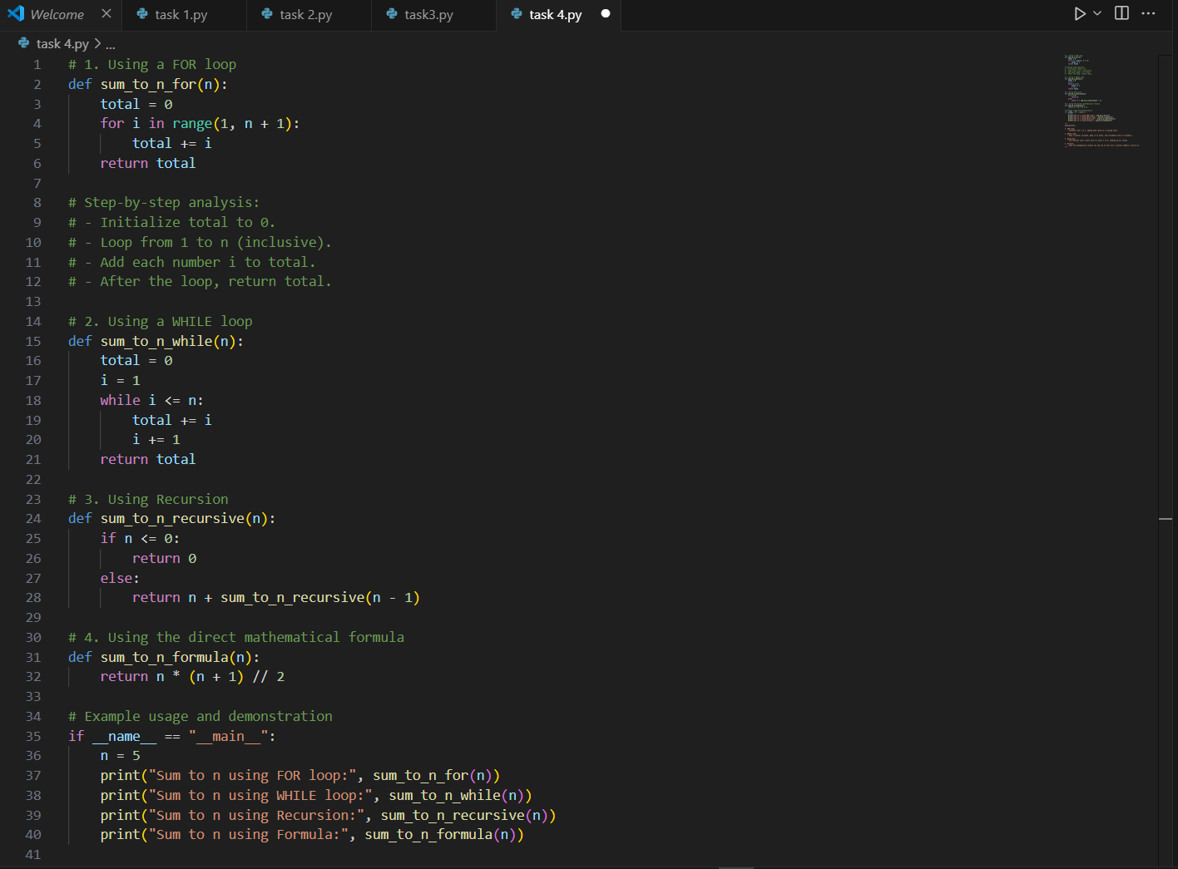  - 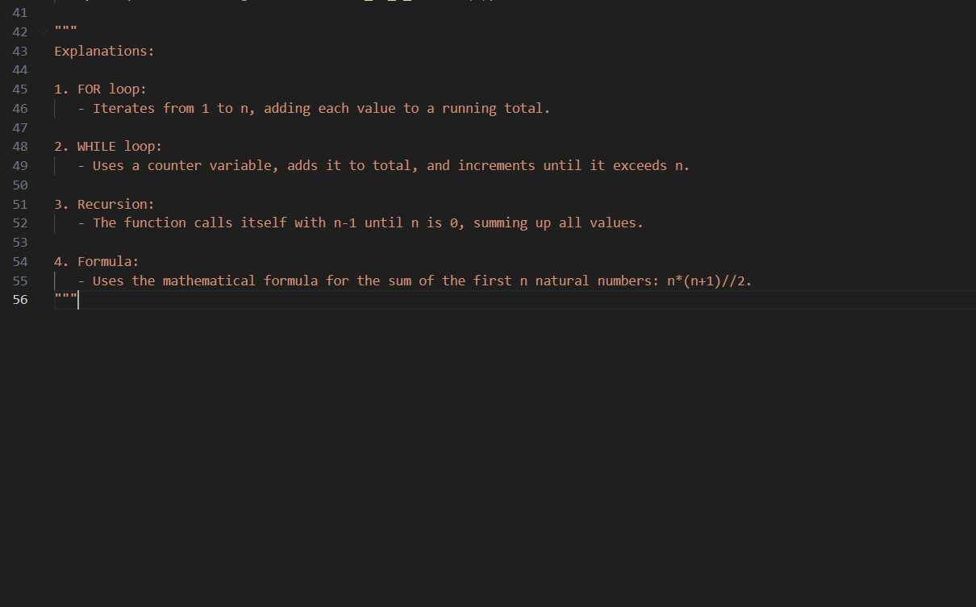  - CURSOR AI CODE:  - 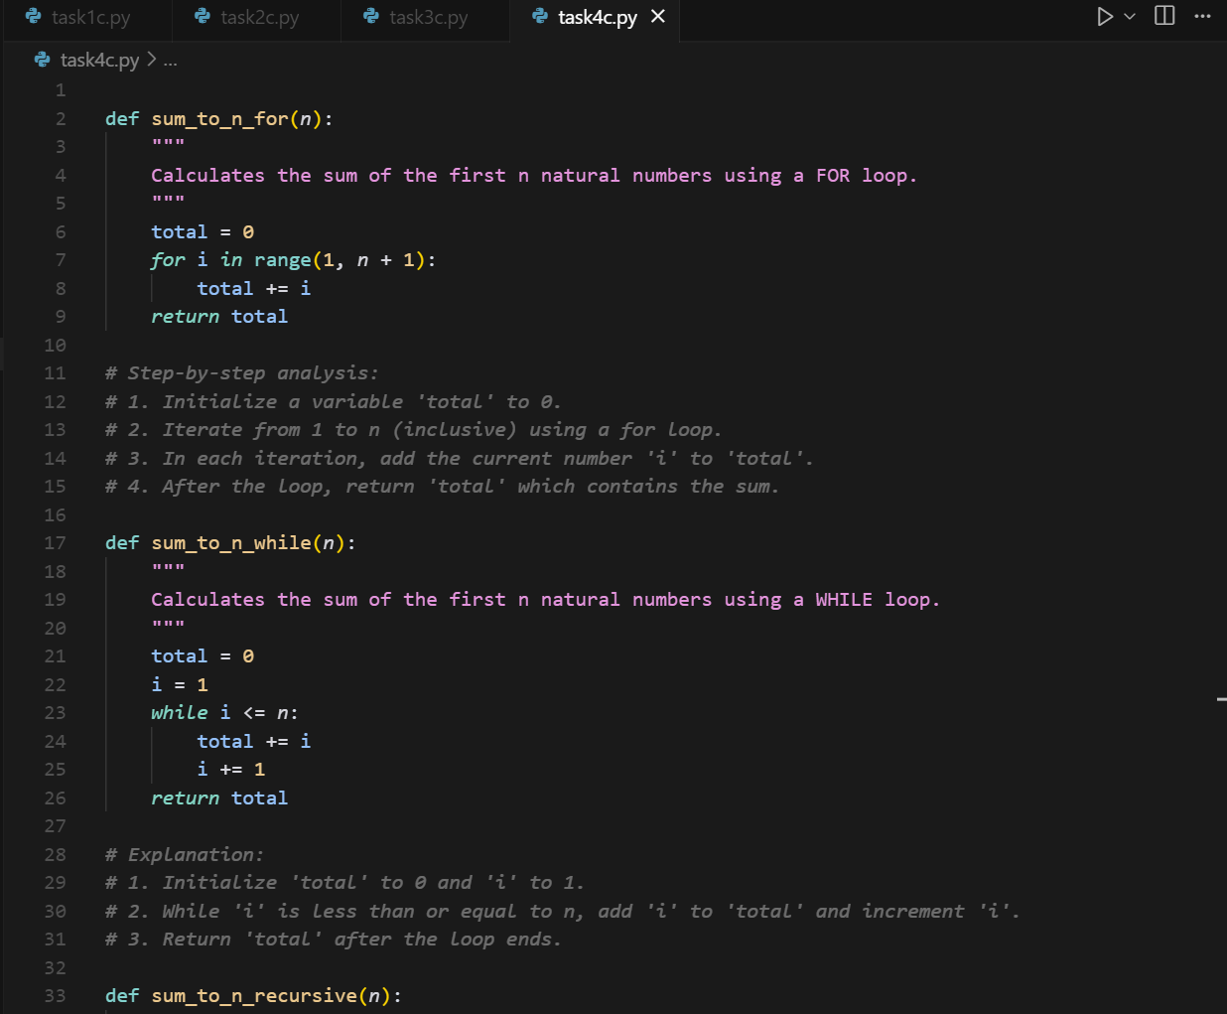  - 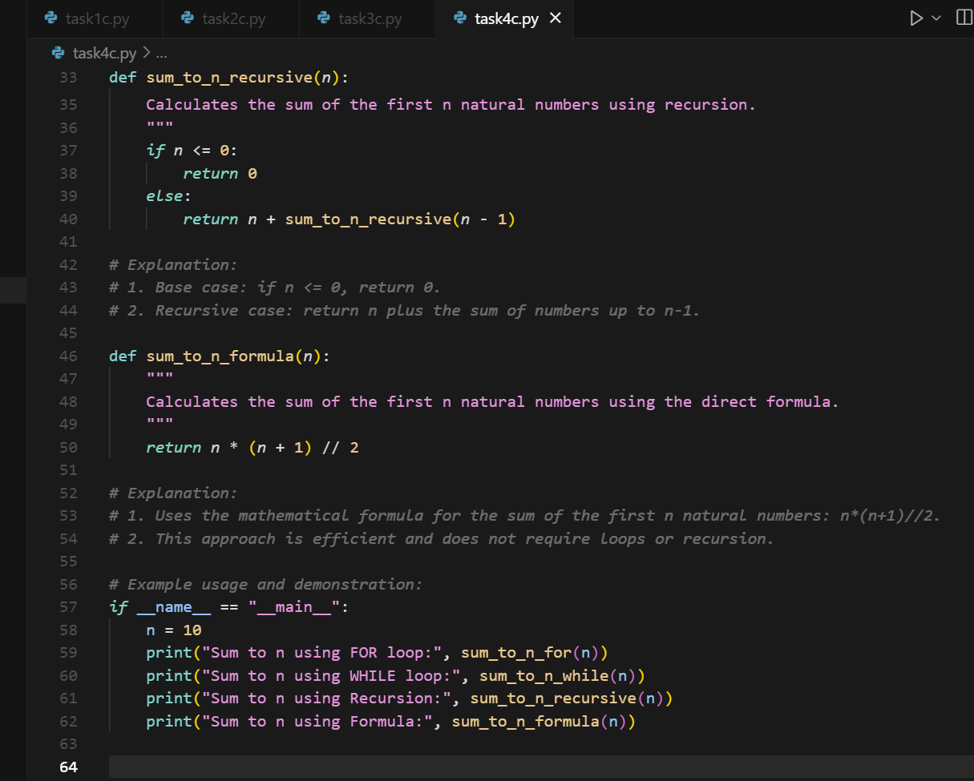  - OUTPUT:  - 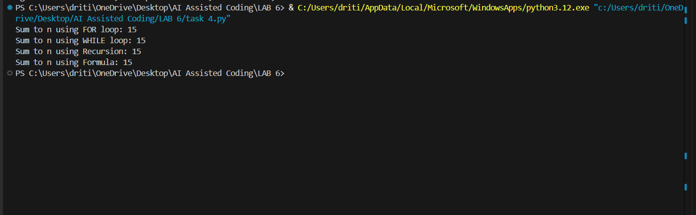  - OUTPUT CURSOR:  - 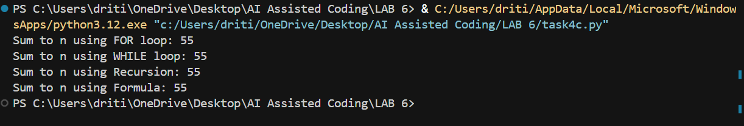  - EXPLANATION:  - The code generated by Cursor AI is more structured and readable compared to the VS Code AI version. Cursor AI includes clear docstrings for each function, explaining their purpose, while the VS Code AI version lacks these. Cursor also provides step-by-step comments directly below each function, making it easier to follow, whereas VS Code AI places a single explanation block at the end. The Cursor AI code has better formatting and spacing, giving it a cleaner look. In the example usage, Cursor AI uses n = 10 for demonstration, while VS Code AI uses n = 5. Overall, Cursor AI's output feels more polished and educational, while VS Code AI's version is more minimal and straightforward.  Task Description#5 (Class)  - Use AI to build a BankAccount class with deposit, withdraw, and balance methods.  - Analyze the generated code  - Add comments and explain code  Instructions  - Initialize BankAccount class with attributes like name, balance  - Method to deposit amount  - Method to withdraw amount  - Method to check balance  Expected Output#5  - Python code with explanation  - 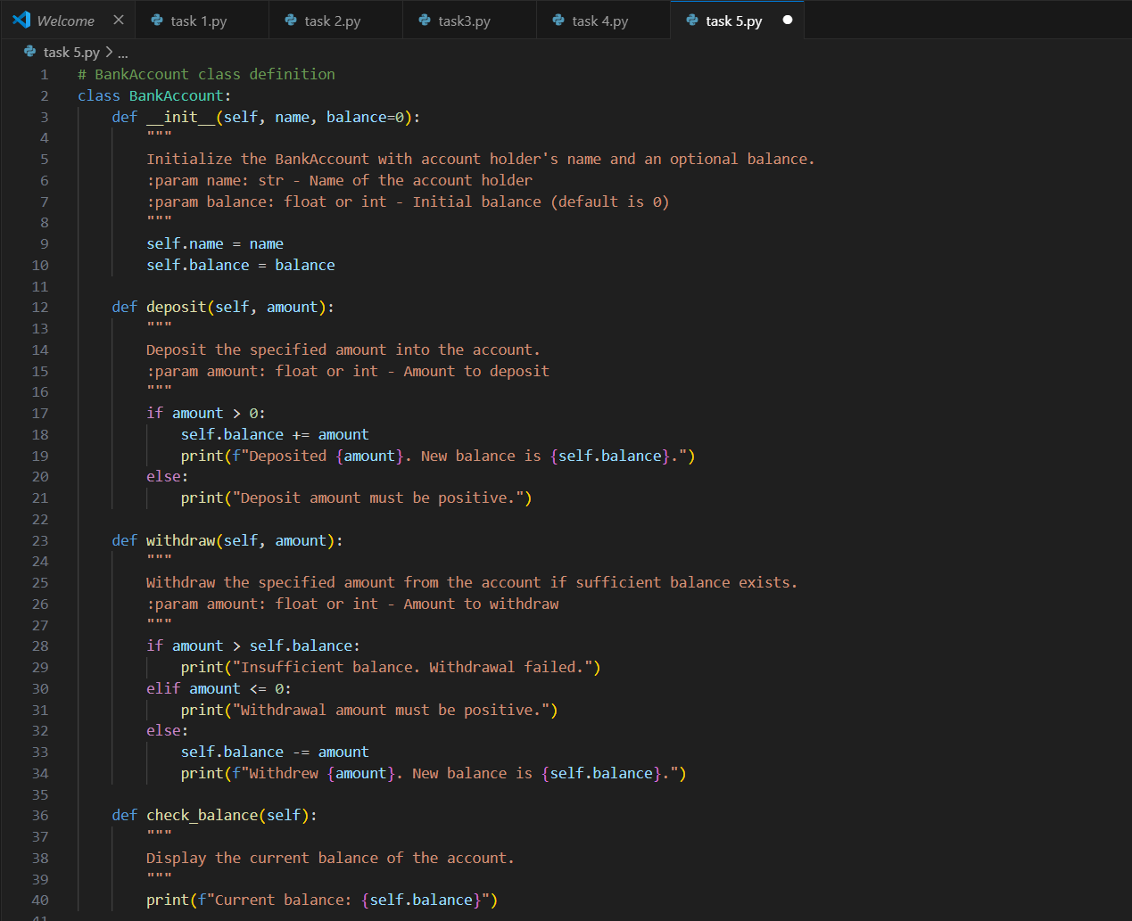  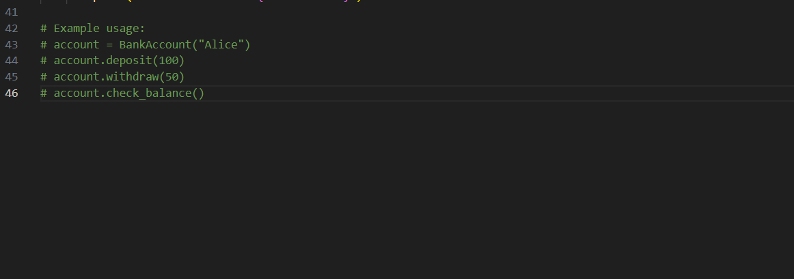  CURSOR AI CODE:  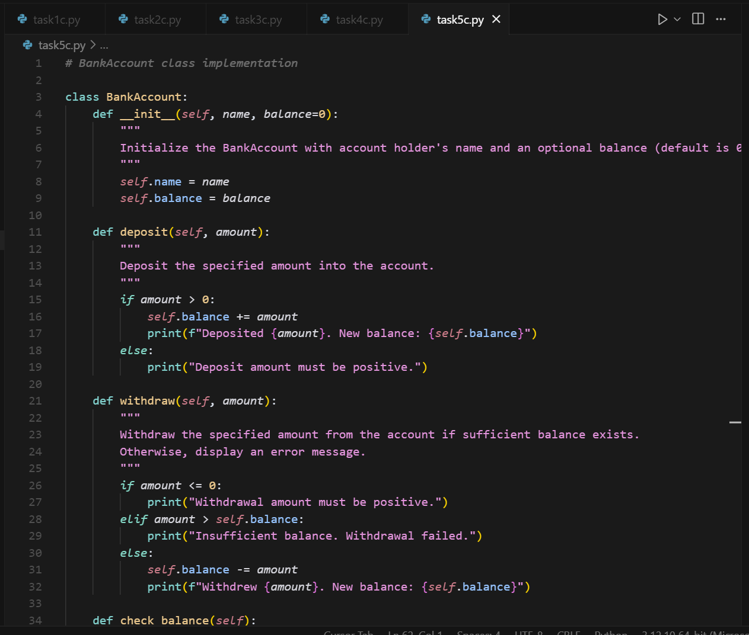  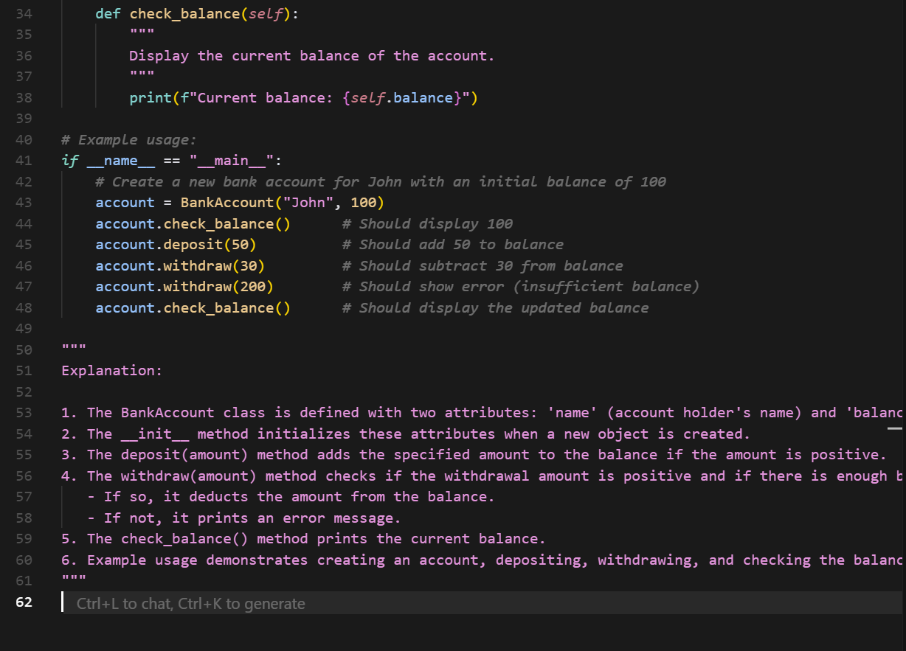  OUTPUT:  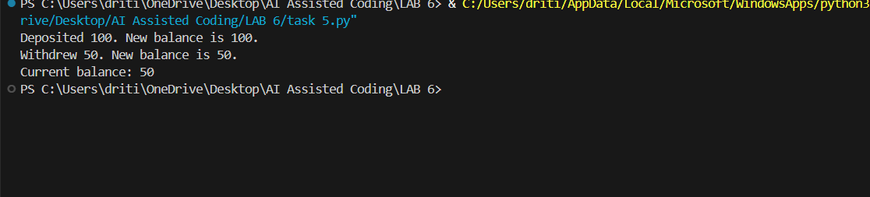  CURSOR OUTPUT:  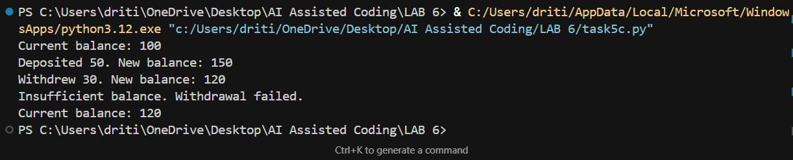  EXPLANATION:  Here is a brief paragraph describing the differences between the VS Code AI and Cursor AI versions of the BankAccount class code, easy to copy and paste:  The Cursor AI code is more polished and beginner-friendly compared to the VS Code AI version. It includes a detailed __main__ block with multiple test cases, helpful inline comments, and a full explanation section at the end. In contrast, the VS Code AI version only provides basic functionality and minimal example usage in comments. Cursor AI also has better formatting and improved error messages, making it more informative. Overall, Cursor AI focuses more on clarity and teaching, while VS Code AI provides a simpler and cleaner core implementation.  Note: Report should be submitted a word document for all tasks in a single document with prompts, comments & code explanation, and output and if required, screenshots  Evaluation Criteria:  Criteria Max Marks  Class 1.0  Loops 1.0  Conditional Statements 0.5  Total 2.5 Marks |  |  |  |  |  | Week3 - Wednesday

